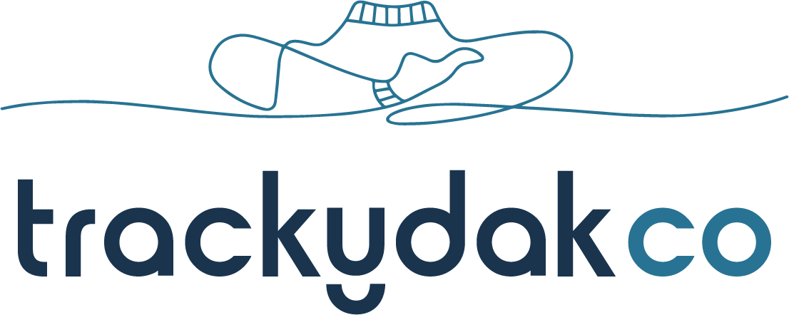

THE BOUNCE FOR LIFE™ PROGRAM
Bounce (verb) To spring back, to be elastic

BOUNCE FOR LIFE™ is a one-on-one or small group coaching program designed to equip teens with lifelong tools to navigate and live their best life.

Why is this Important?
We all have good days and bad. But when things start to get overwhelming, it’s important to find out how we can manage it.
Trackydak helps teens to meet their challenges with curiosity and openness. It is in this mindset shift that teens can harness their true power and craft a truly empowered story for their life.
Without tools to BOUNCE AT LIFE™, life can become hard. More than 15% of Australian kids (16-24) experience anxiety disorders, and a recent survey showed that 56% of females and 25% of males describe their stress as ‘extremely or very concerning’.
Teens, now more than ever, need deep, individualised attention, especially when it comes to intrapersonal and interpersonal challenges.
Equipping your students with an ability to BOUNCE FOR LIFE™ is one of the greatest gifts you could give as they grow into adulthood.
PROGRAM FORMAT
The BOUNCE FOR LIFE™ program is a one-on-one or small group, customised experience where we tailor the sessions to your student’s needs*. Topics can include:
- SCHOOL: Discover more empowerment at school so we can ‘do school the easy way’
- ENGAGEMENT: Finding meaning in school when motivation doesn’t show up or fades away
- EMBRACING FAILURE: Looking for lessons and growth opportunity that failure has to offer
- GOAL SETTING: How to plan smart for short-term and long-term goals, and celebrate mini wins along the way
- RESILIENCE: Tap into strengths and support systems to overcome challenges and work through problems
- SELF-TALK: Stop rubbishing self-talk that leaves us feeling small, so we can approach challenges with greater ease
- SELF-BELIEF: Develop inner confidence and take challenges head-on so we can thrive at life
- SELF-COMPASSION & SELF-ACCEPTANCE: Become your own best friend through reflective practices
- STRESS, OVERWHELM & PRESSURE: Know the difference and how to make sense during overwhelm
- ANXIETY, DOUBT & WORRY: Understand and manage rather than try to eliminate these big emotions
- FRIENDSHIPS: The difference between good versus toxic friendships, and how to establish healthy boundaries
- MANAGING SOCIAL CONFLICT: Develop emotional agility and become responsive rather than reactive in the face of social conflict
- SOCIAL MEDIA: Discover how social media affects our self-worth, and how to lead rather than follow with social media savvy
ABOUT TRACEY
Tracey is the owner of Trackydak Co, which she launched following 20 years of teaching and working with youth from all backgrounds, including refugee and at-risk teens.
She was instrumental in designing an anti-bullying program in her school which is still running today. Tracey’s innovative programs and passion for teen empowerment culminated in her winning National Teacher of the Year 2009, personally handed to her from the Prime Minister of Australia.
Tracey sees the light in all teens. No matter what teens present on the outside, she knows a light shines bright within, and having ‘true believers’ in their corner will catalyse their highest potential.
ABOUT THE PROGRAM
- Teens develop their personalities over decades, and often have unique challenges that take time to work through. There is no magic wand but there is a process that works.
- The BOUNCE FOR LIFE™ program is delivered one-on-one or in small groups to help teens craft more positive ways to respond to life’s pressures
- Teens are involved in session planning. This gives them self-agency in designing the best possible outcome for their life, and leads to greater engagement in the process

If you still have questions, contact Tracey on 0401690188 or info@trackydakco.com

* If students are experiencing acute challenges (such as bullying or study overwhelm) sessions can be tailored to focus on these key topics.

Mission Australia Youth Survey Report 2022, news.com.au.

